1. Log in to putty server. Provide Host Name and click open

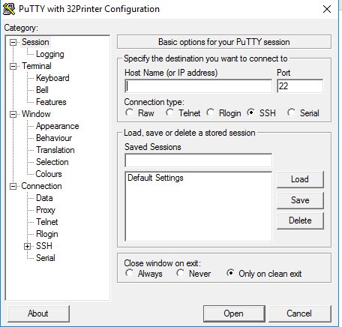

1. Enter user name and password. Give enter

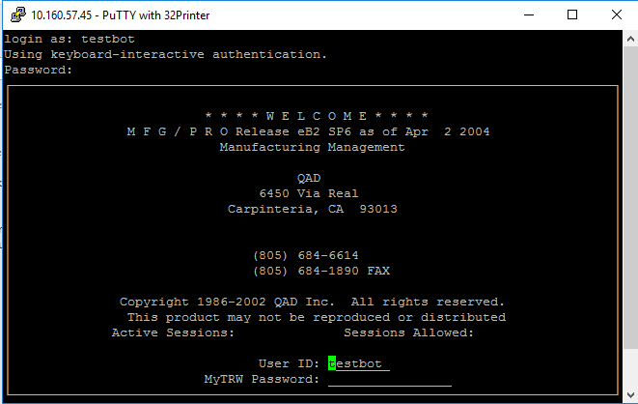

Again give username and password and give enter.

1. Enter menu option and give enter.

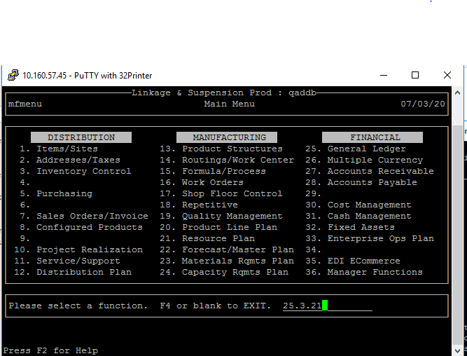

1. Enter 32prn in output field and give enter.

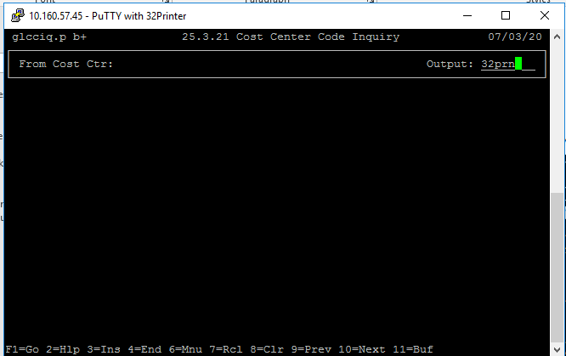

1. Select SEND To Excel and Report 132 Portrait and click go.

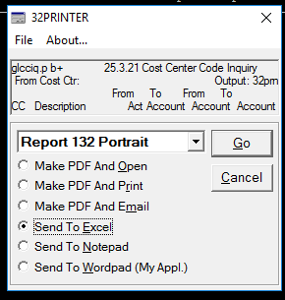

1. Save your excel and move data in sharepoint list.
2. Send generated report to Kranti and bharti in mail.